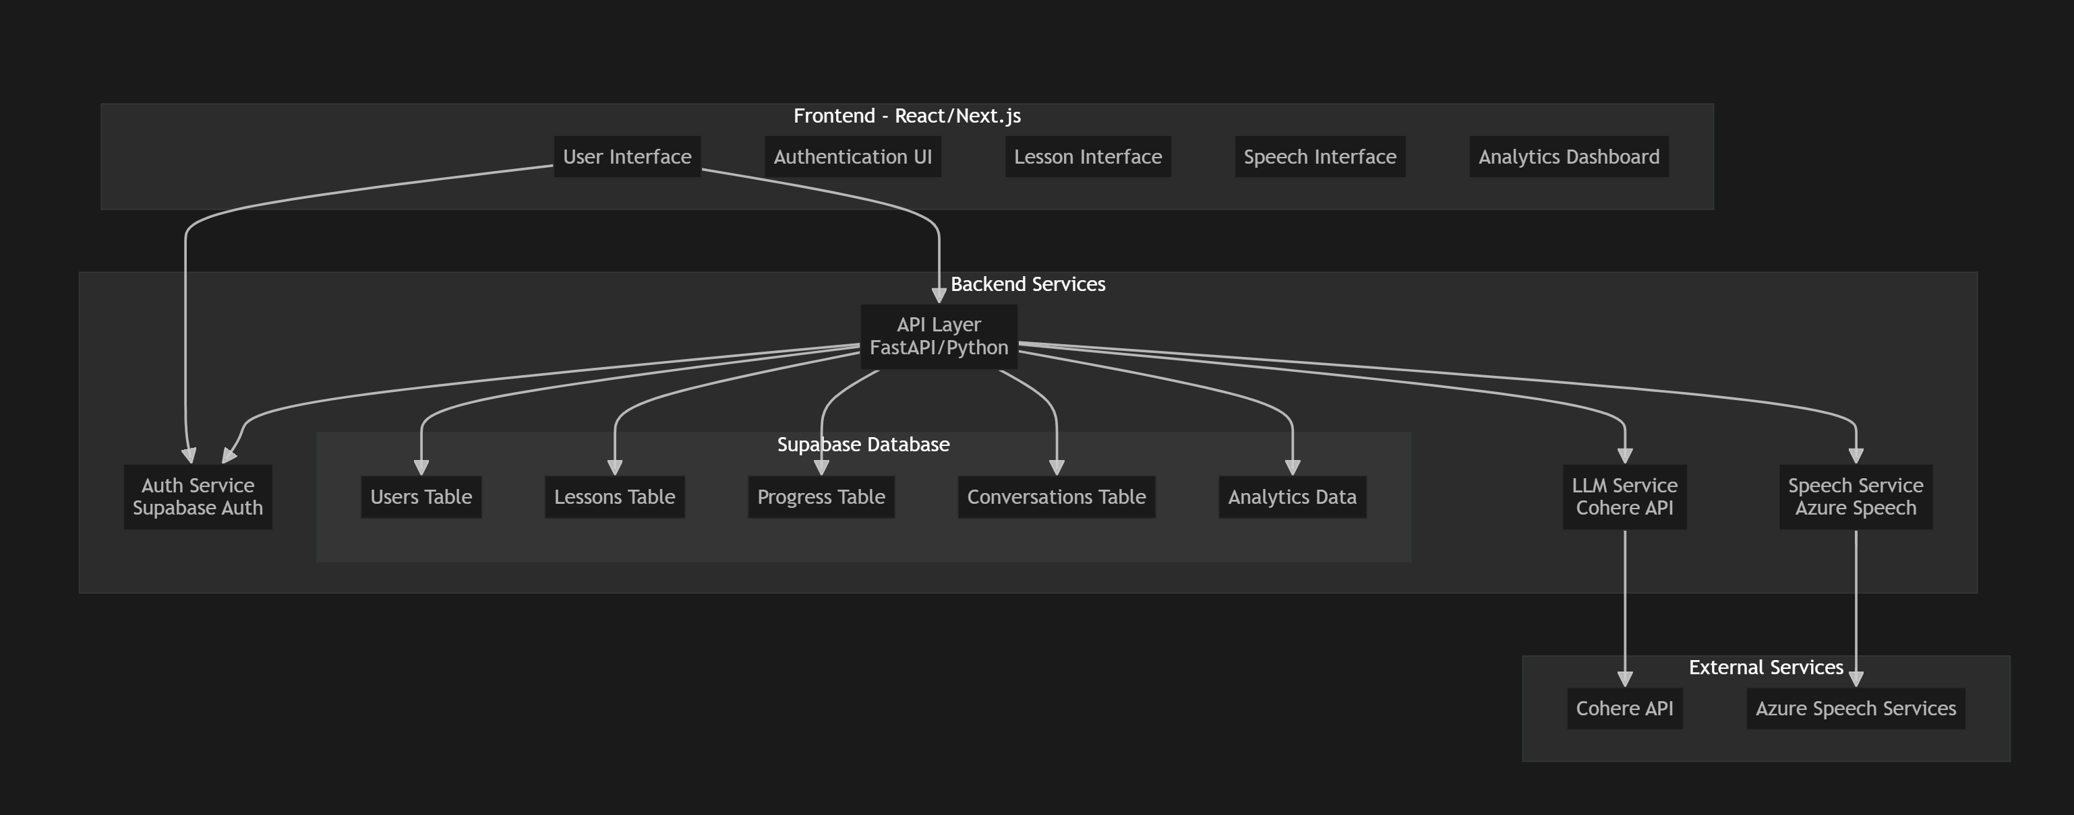

Let me break down the complete system architecture for your English teaching app:
- Frontend Layer (React/Next.js)
- Core Components:
- Authentication UI (login, registration, profile)
- Lesson Interface (interactive learning environment)
- Speech Interface (real-time speech interaction)
- Analytics Dashboard (progress tracking)
- Features:
- Responsive design for mobile/desktop
- Real-time speech recognition/synthesis
- Interactive lesson UI
- Progress visualization
- Backend Services (FastAPI/Python)
- API Layer:
- RESTful endpoints for all features
- WebSocket support for real-time communication
- Request validation and error handling
- Service Modules:
- Auth Service (Supabase Auth)
- User authentication and authorization
- JWT token management
- Social auth integration (if needed)
- LLM Service (Cohere)
- Conversation management
- Language correction
- Lesson generation
- Writing feedback
- Speech Service (Azure)
- Speech-to-text conversion
- Text-to-speech synthesis
- Pronunciation assessment
- Database Layer (Supabase)
- Tables:
1. -- Users table
2. users (
3. id uuid primary key,
4. email text unique,
5. full_name text,
6. language_level text,
7. learning_goals jsonb,
8. created_at timestamp,
9. last_login timestamp
10. )
11.
12. -- Lessons table
13. lessons (
14. id uuid primary key,
15. user_id uuid references users(id),
16. title text,
17. content jsonb,
18. type text,
19. difficulty level,
20. created_at timestamp
21. )
22.
23. -- Progress table
24. progress (
25. id uuid primary key,
26. user_id uuid references users(id),
27. lesson_id uuid references lessons(id),
28. score numeric,
29. completed_at timestamp,
30. feedback jsonb
31. )
32.
33. -- Conversations table
34. conversations (
35. id uuid primary key,
36. user_id uuid references users(id),
37. messages jsonb[],
38. context text,
39. created_at timestamp
40. )
41.
42. -- Analytics table
43. analytics (
44. id uuid primary key,
45. user_id uuid references users(id),
46. metric_type text,
47. metric_value jsonb,
48. recorded_at timestamp
49. )
50.

- External Services Integration
- Cohere API Integration:
- Chat completion endpoints
- Prompt engineering for different lesson types
- Error handling and rate limiting
- Azure Speech Services:
- Real-time speech recognition
- Natural text-to-speech conversion
- Accent and pronunciation analysis
- Security Measures
- JWT-based authentication
- HTTPS encryption
- API rate limiting
- Input validation
- Secure storage of API keys using environment variables
- Deployment Architecture
1. /backend
2. ├── api/
3. │ ├── routes/
4. │ │ ├── auth.py
5. │ │ ├── lessons.py
6. │ │ ├── speech.py
7. │ │ └── analytics.py
8. │ ├── services/
9. │ │ ├── cohere_service.py
10. │ │ ├── speech_service.py
11. │ │ └── supabase_service.py
12. │ └── utils/
13. │ ├── auth.py
14. │ └── helpers.py
15. ├── tests/
16. └── config/
17.
18. /frontend
19. ├── components/
20. │ ├── auth/
21. │ ├── lessons/
22. │ ├── speech/
23. │ └── common/
24. ├── pages/
25. ├── styles/
26. └── utils/
27.

- Key Features to Implement:
- Real-time conversation practice
- Automated grammar correction
- Pronunciation feedback
- Progress tracking and analytics
- Personalized lesson generation
- Speech recognition and synthesis
- User profile and progress management
- Scalability Considerations:
- Implement caching for frequently accessed data
- Use connection pooling for database
- Implement rate limiting for API endpoints
- Consider serverless deployment for cost optimization

